SOUTH INDIA SPLENDORS


Circuit: Chennai – Kanchipuram – Mahabalipuram – Pondicherry – Gangaikondacholapuram – Darasuram
– Tanjore – Trichy – Madurai – Alleppey – Kumarakom - Kovalam
ITINERARY PUBLISHED:
15 Nov’26: | ARRIVAL CHENNAI
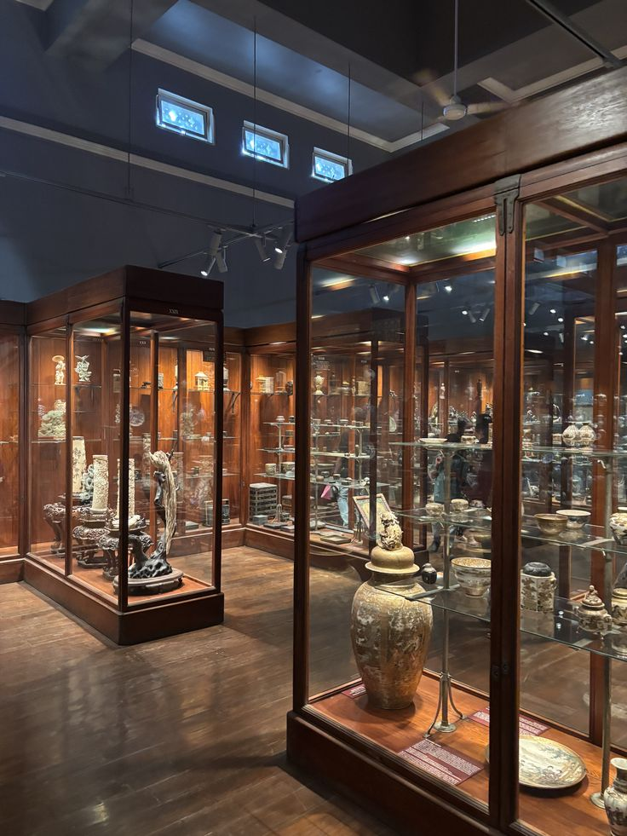
Meeting and assistance upon arrival at Chennai International Airport and transfer to the hotel. Upon arrival, check in at hotel in Chennai.

Afternoon proceed for half day Chennai Sightseeing – A Glimpse into Tamil Nadu’s Heritage: Begin your exploration of Chennai with a visit to the Government Museum, renowned for its remarkable collection of South Indian art and antiquities. Admire the exceptional Bronze Gallery, featuring a superb collection of exquisite Chola bronzes that beautifully reflect the artistic mastery, craftsmanship, and spiritual traditions of the Chola dynasty. Continue with a drive through the vibrant flower and fruit markets, offering a colourful glimpse into the everyday rhythm of Chennai. Proceed past the magnificent Madras High Court, an impressive landmark built in the distinctive Indo-Saracenic architectural style, showcasing the city’s rich colonial heritage. Continue to Fort St. George and visit the Fort Museum, which houses an interesting collection of colonial memorabilia, historic artefacts, weapons, uniforms, and other exhibits that bring Chennai’s colonial past vividly to life.

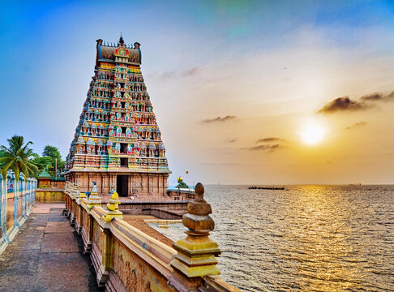
Drive along Marina Beach, one of Chennai’s most celebrated landmarks and among the longest urban beaches in the world. Take in the refreshing sea breeze and observe the lively atmosphere along the beachfront, where local life unfolds against the vast expanse of the Bay of Bengal. Continue to the San Thome Cathedral, an elegant neo-Gothic basilica traditionally associated with the final resting place of St. Thomas the Apostle, offering an intriguing connection between Chennai and the early Christian history of India. The sightseeing continues with a visit to the magnificent Kapaleeshwarar Temple, dedicated to Lord Shiva and celebrated for its vibrant Dravidian architecture, intricately sculpted gopuram, and deeply rooted religious traditions. Conclude the tour with a visit to the Guindy Snake Park, home to a fascinating variety of reptiles and an interesting insight into India’s diverse wildlife. Together, these experiences reveal the many facets of Chennai—from Chola artistry and Dravidian spirituality to colonial architecture, vibrant markets, Christian heritage, and coastal charm, offering an enriching introduction to the cultural character of Tamil Nadu.

Dinner & overnight stay at hotel in Chennai

16 NOV’26: | CHENNAI – KANCHIPURAM – MAHABALIPURAM (150Kms, 03Hrs Drive)
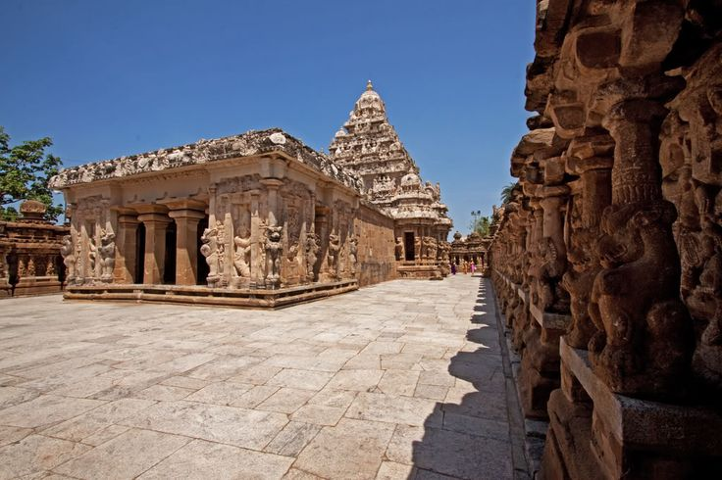
Morning after breakfast start your drive to Mahabalipuram enroot visiting Kanchipuram – The Sacred City of Temples and Silk: Journey to Kanchipuram, the ancient capital of the Pallava dynasty, situated approximately 64 kilometres from Chennai. Revered as one of the seven sacred cities of India, Kanchipuram is a remarkable destination where centuries-old temples, exquisite architecture, and traditional craftsmanship come together to create a fascinating cultural experience. The city traces its illustrious history back to the early Chola period and was once believed to be home to nearly a thousand temples, of which around two hundred continue to stand today as enduring symbols of South India’s architectural and spiritual heritage. The town is particularly vibrant during its celebrated temple car festivals, traditionally held between January and May. Begin with the magnificent Kailasanatha Temple, dating from the 7th century and regarded as the oldest surviving temple in Kanchipuram. Built during the Pallava era, the temple is admired for its elegant Dravidian architecture, intricate carvings, and beautifully sculpted details, making it one of the most treasured monuments in the city. Continue to the impressive Varadaraja Perumal Temple, associated with the Vijayanagara period and renowned for its remarkable craftsmanship. Its celebrated 96-pillared marriage hall features an extraordinary array of sculptural details, while the principal shrine is situated upon a distinctive elephant-shaped rock. Explore further to discover the Ekambaresvara Temple, one of the most important Shiva temples in Kanchipuram, and the Vaikuntha Perumal Temple, an exceptional example of Pallava architecture distinguished by its historic significance and intricate sculptural work.

Continue drive to Mahabalipuram. Upon arrival check in at hotel in Mahabalipuram.

Dinner & overnight stay at hotel in Mahabalipuram

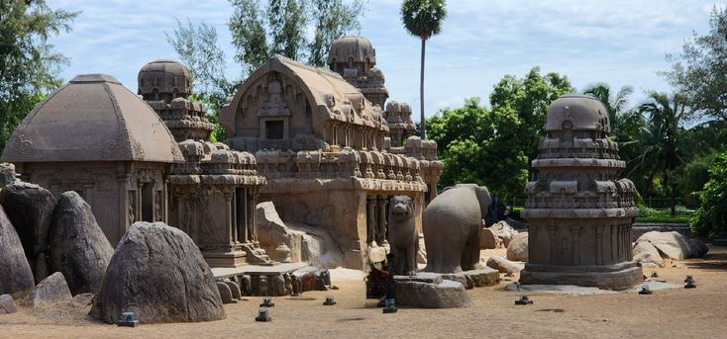
17 NOV’26: | MAHABALIPURAM – PONDICHERRY (96Kms, 02Hrs drive)
Morning after breakfast proceed for sightseeing tour of Mahabalipuram – A Masterpiece of Pallava Art and Architecture: Explore Mahabalipuram, an extraordinary coastal heritage town renowned for its magnificent rock-cut temples and masterful stone sculptures dating from the 7th and 8th centuries. Developed under the Pallava dynasty, the monuments represent a remarkable chapter in the evolution of Dravidian architecture and stand as a testament to the exceptional artistry and craftsmanship of ancient South India.cThe complex comprises 14 rock-cut cave temples, nine monolithic Rathas, three structural stone temples, and four magnificent rock-cut sculptural panels, creating an exceptional ensemble of historic monuments. Many of these masterpieces are dedicated to the Hindu deities Shiva and Vishnu, while their elaborate carvings bring to life an extraordinary world of mythology, devotion, nature, and everyday existence.cVisit the iconic Shore Temple, dramatically positioned overlooking the Bay of Bengal and recognised as a UNESCO World Heritage Site. Built from finely dressed stone, the temple is one of Mahabalipuram’s most celebrated landmarks and offers a particularly atmospheric experience against the coastal landscape.

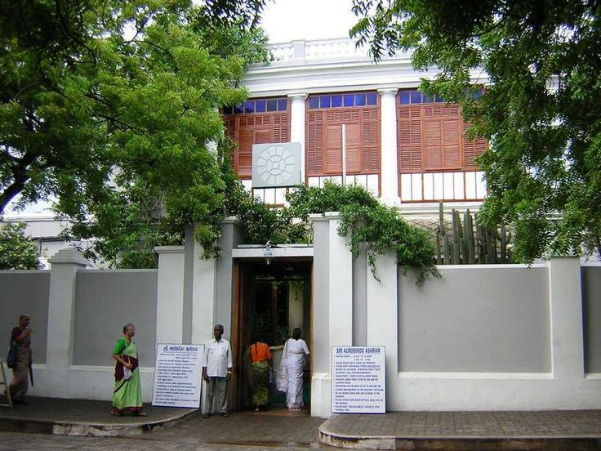
Continue to Arjuna’s Penance, one of the largest open-air rock reliefs in the world, where an immense sculpted panel portrays an intricate composition of gods, celestial beings, animals, and scenes inspired by Hindu mythology.cDiscover the remarkable Five Rathas, a group of monolithic temples carved entirely from individual granite outcrops. Each ratha displays distinctive architectural features, offering fascinating insight into the experimental development of temple design during the Pallava period. The exploration continues through the ancient Mandapams, or rock-cut halls, adorned with beautifully carved pillars and elaborate reliefs depicting Hindu deities, legendary tales, animals, mythical creatures, and captivating scenes from daily life. Later continue drive to Pondicherry. Upon arrival check in at hotel in Pondicherry. Afternoon proceed for sightseeing tour of Pondicherry – A Graceful Blend of Spirituality and French Heritage: Embark on a half-day exploration of Pondicherry, a charming former French settlement where spiritual traditions, colonial heritage, and laid-back coastal elegance come together in a uniquely captivating atmosphere. Begin with a visit to the Sri Aurobindo Ashram, founded in 1926 by the philosopher, spiritual thinker, and yogi Sri Aurobindo. Established with the vision of creating a peaceful and spiritually enriched community, the Ashram became a centre for integral yoga and contemplative living. Its philosophy seeks to bring together spiritual wisdom with the insights of modern life and thought. The Ashram also serves as the final resting place of Sri Aurobindo and remains an important centre of spiritual reflection. Continue to the Pondicherry Museum, which houses an impressive collection of sculptures, archaeological discoveries, and historical artefacts offering fascinating insights into the region’s ancient past and its successive cultural influences. The museum also preserves memorabilia associated with the period of French rule, reflecting Pondicherry’s distinctive colonial legacy. Conclude the visit with the Basilica of the Sacred Heart of Jesus, an impressive example of Gothic-inspired architecture. Admire its elegant façade, soaring proportions, and beautiful stained-glass windows, which add a serene and contemplative character to this celebrated place of worship. This half-day experience offers a fascinating introduction to Pondicherry’s unique identity, revealing a destination where spirituality, history, architecture, and French cultural influences have evolved harmoniously side by side.

Dinner & overnight stay at hotel in Pondicherry.

18 NOV’26: | PONDICHERRY – GANGAIKONDA CHOLAPURAM – DARASURAM – TANJORE
(181Kms, 03Hrs drive)
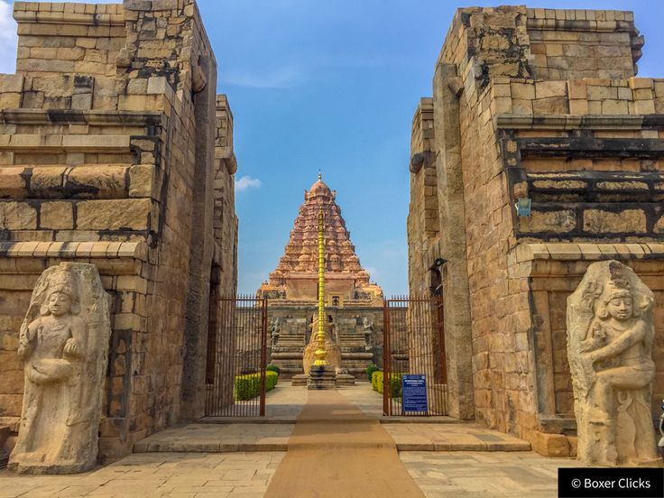
Morning after breakfast drive to Tanjore enroot visiting Gangaikondacholapuram – Echoes of Chola Grandeur: Step into the remnants of Gangaikondacholapuram, once the magnificent capital of the Chola dynasty and whose name translates as “The City of the Chola Who Conquered the Ganga.” Although the ancient city has largely disappeared, its surviving monuments offer a fascinating glimpse into the power, artistic brilliance, and architectural sophistication of the Chola Empire. The centrepiece of the site is the magnificent Brihadishvara Temple, an imposing example of Chola architecture built in the 11th century. Rising majestically above the surrounding landscape, its ornate vimana reaches approximately 55 metres in height and is adorned with beautifully executed sculptures and intricate architectural details. Within the temple complex, admire finely carved representations of Hindu deities and the imposing Nandi, the sacred bull associated with Lord Shiva. The artistry of the sculptures reflects the remarkable craftsmanship achieved during the Chola period. Another fascinating remnant of the ancient capital is the approximately 5-kilometre-long reservoir embankment, a remarkable testament to the Cholas’ advanced understanding of water management and engineering. Together with the temple, it provides a powerful sense of the scale and ambition of the city that once flourished here. Today, the site has been carefully restored, allowing visitors to appreciate the enduring legacy of one of South India’s most influential imperial dynasties. A visit to Gangaikondacholapuram is an evocative journey into the grandeur of the Chola era, where monumental architecture, exquisite sculpture, and remarkable engineering continue to preserve the memory of a once-great imperial capital.

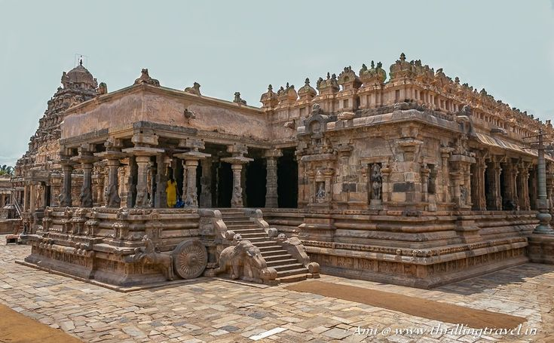
Airavateshvara Temple, Darasuram – A Sculptor’s Dream in Stone: Discover the magnificent Airavateshvara Temple at Darasuram, a remarkable masterpiece of 12th-century Chola architecture and one of Tamil Nadu’s most treasured expressions of artistic and architectural excellence. Often described as a “sculptor’s dream in stone,” the temple captivates visitors with its extraordinary carvings, musical pillars, ornate mandapams, and wealth of exquisite sculptures. Dedicated to Lord Shiva, the temple is celebrated for the remarkable precision and refinement of its stonework. Among its most fascinating features is the intricately designed chariot-shaped mandapam, whose sculptural detailing creates the impression of a magnificent stone chariot drawn across the temple precinct. The temple’s celebrated musical pillars and finely carved panels further reveal the exceptional skill of the Chola artisans. Throughout the complex, sculptures depicting deities, celestial figures, mythical beings, and scenes from Hindu traditions showcase the extraordinary imagination and craftsmanship of the period. Traces of ancient painting add yet another dimension to this remarkable monument. Darasuram, an ancient town located approximately 380 kilometres south of Chennai, was originally known as Rajarajapuram, a name that gradually evolved into its present form, Darasuram. Beyond its architectural heritage, the town is also known for its traditional silk-weaving tradition, continuing a long-standing craft heritage of the region. A visit to Airavateshvara Temple offers a fascinating journey into the artistic brilliance of the Chola dynasty, where stone appears to come alive through sculpture, architecture, music, and mythology, making Darasuram an unforgettable highlight for travellers exploring Tamil Nadu’s magnificent temple heritage.

Continue drive to Tanjore. Upon arrival check in at hotel in Tanjore.

Rest of the day free for relaxation/independent activities.

Dinner & overnight stay at hotel in Tanjore
19 NOV’26: | TANJORE
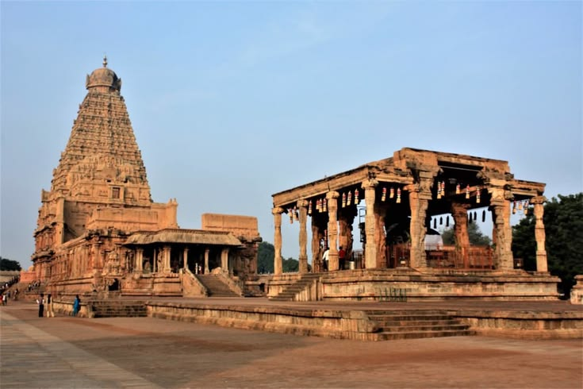
Morning after breakfast proceed for sightseeing tour of Thanjavur – A Monument to Chola Grandeur: Visit the magnificent Sri Brihadisvara Temple, an architectural masterpiece dating from the 11th century and one of the finest expressions of the artistic and engineering brilliance of the Chola dynasty. Built predominantly from enormous blocks of granite, the temple is adorned with exquisite sculptures, intricate carvings, and beautifully preserved frescoes that reflect the extraordinary craftsmanship of its era. The temple is crowned by its awe-inspiring monolithic dome, fashioned from a single granite stone weighing approximately 80 tonnes. Its placement at such an extraordinary height remains a remarkable feat of ancient engineering. According to the traditional account, the massive stone was hauled to the summit using an approximately 6-kilometre-long inclined ramp, employing a technique often compared with the methods associated with the construction of the Egyptian pyramids. Beyond its impressive scale, the temple's harmonious proportions, intricate ornamentation, and monumental presence offer a profound insight into the vision and sophistication of the Chola rulers and artisans. A visit to Brihadisvara Temple is an opportunity to witness a remarkable fusion of devotion, artistic mastery, architectural precision, and engineering ingenuity, making it one of the most unforgettable heritage experiences in Tamil Nadu.

Dinner & overnight stay at hotel in Tanjore

20 NOV’26: | TANJORE – TRICHY – MADURAI (191Kms, 03Hrs drive)
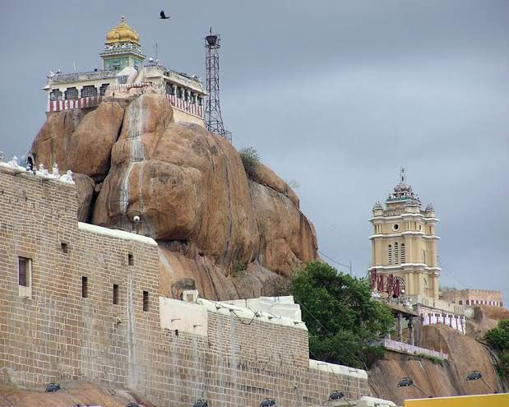
Morning after breakfast explore Tiruchirappalli (Trichy), a fascinating city where dramatic landscapes, ancient rock-cut architecture, and magnificent temple traditions come together. Begin with a visit to the celebrated Rock Fort, dramatically perched atop an imposing 84-metre-high rock. Reaching the summit involves climbing 437 rock-cut steps, an experience that rewards visitors with spectacular views over the city and the surrounding landscape. At the summit stands the revered Vinayak Temple, dedicated to Lord Ganesha. The rock also houses a historic Shiva Temple and several ancient cave temples, distinguished by beautifully carved pillars, sculpted panels, and intricate details hewn directly from the living rock. Continue to the magnificent Sri Ranganathaswamy Temple at Srirangam, one of the most important Vaishnavite pilgrimage centres in India and an extraordinary example of South Indian temple architecture. Dedicated to Lord Vishnu, the vast temple complex is enclosed within seven concentric walled courtyards and entered through 21 magnificent gateways, creating an impressive architectural sequence. Within these sacred precincts are numerous shrines, richly decorated structures, traditional bazaars, and bustling streets that continue to form an integral part of the temple’s living cultural landscape. The scale and intricate detailing of the complex offer a fascinating insight into the religious traditions, architectural ingenuity, and enduring spiritual heritage of Tamil Nadu. Together, the Rock Fort and Srirangam reveal two distinctive facets of Trichy’s heritage—from ancient rock-cut artistry and commanding landscapes to monumental temple architecture and living traditions, making the city a compelling highlight of any journey through South India.

Continue drive to Madurai. Upon arrival check in at hotel in Madurai.

Evening witness aarti ceremony at Meenakshi Temple.

Dinner & overnight stay at hotel in Madurai.

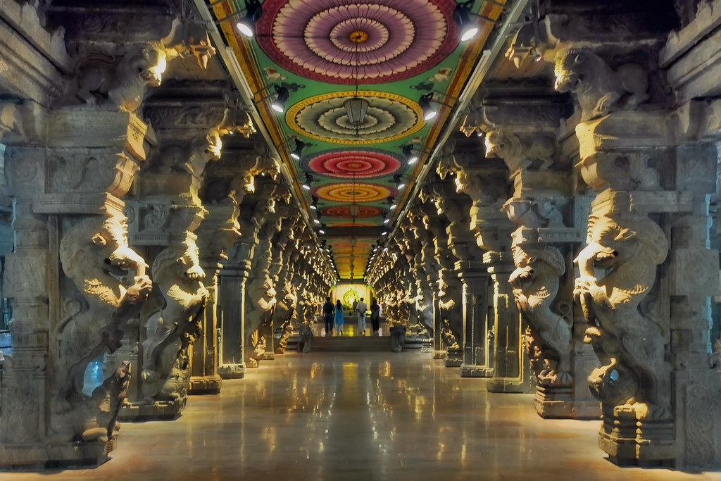
21 NOV’26: | MADURAI
Morning after breakfast proceed for sightseeing tour of Madurai – The Soul of Tamil Nadu: Embark on a full-day exploration of Madurai, one of South India’s oldest and most culturally vibrant cities, renowned for its magnificent temples, fascinating history, and enduring traditions. Begin with a visit to the spectacular Meenakshi Amman Temple, one of the finest expressions of Dravidian temple architecture and the spiritual heart of Madurai. Dedicated to Goddess Meenakshi, the consort of Lord Shiva, this vast temple complex is celebrated for its towering gopurams, richly adorned with thousands of colourful stucco figures depicting gods, goddesses, celestial beings, and animals. The intricate sculptures, grand halls, and ornate details reflect the extraordinary artistic traditions of Tamil Nadu. The inner sanctuary is traditionally accessible only to Hindus. Continue to the elegant Thirumalai Nayak Palace, an impressive 17th-century monument built during the reign of the Nayak rulers. The palace is admired for its graceful Indo-Saracenic architectural character, monumental arches, lofty domes, and elaborate stucco ornamentation. Its imposing proportions and refined decorative details provide a fascinating glimpse into the grandeur of Madurai’s royal past. Later, venture towards the picturesque Alagar Hills, approximately 20 kilometres from Madurai, a scenic area steeped in mythology and religious significance. Continue to Tirupparankundram, home to the historic rock-cut temple dedicated to Lord Murugan. Carved into the hillside, the temple is revered as one of the important sacred shrines associated with Murugan and offers an evocative combination of spirituality, ancient architecture, and natural surroundings. A day in Madurai provides a captivating encounter with the spiritual, artistic, and royal heritage of Tamil Nadu, where magnificent temples, historic palaces, sacred hills, and living traditions come together to create an unforgettable cultural experience.

Dinner & overnight stay at hotel in Madurai

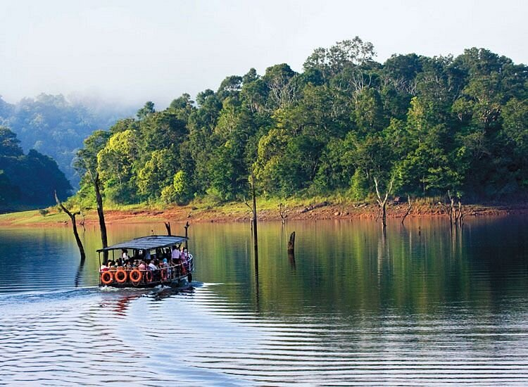
22 NOV’26: | MADURAI – PERIYAR (150Kms, 03Hrs drive)
Moring after breakfast drive to Periyar. Upon arrival check in at hotel in Periyar. Afternoon proceed for spice plantation in Periyar Kumily – A Fragrant Journey Through Kerala’s Spice Country: Take a leisurely walk through the charming streets of Kumily or along the winding pathways that meander through its lush plantations, and one of the first impressions is the captivating fragrance that fills the air. The aromas of cardamom, cinnamon, cloves, nutmeg, and pepper drift gently through the plantations, sometimes blending together to create a distinctive natural perfume unique to this region. Blessed with a cool climate, fertile soil, and an elevation that is particularly favourable for cultivation, Kumily lies at the heart of Kerala’s celebrated spice-growing country. The region’s natural conditions have made it especially renowned for the cultivation of cardamom, one of Kerala’s most prized spices. Among the principal varieties grown here is small cardamom (Elettaria cardamomum), whose graceful, shrub-like plants flourish at elevations of approximately 600 to 1,200 metres above sea level. Kerala has long been one of India’s leading cardamom-producing regions, with the plantations around Kumily contributing significantly to its reputation as a centre of spice cultivation. The pepper plantations offer another enchanting sight. Pepper vines climb gracefully around their supporting trees, while shafts of sunlight filter through the foliage, creating an atmospheric interplay of light and green that is particularly captivating during a plantation walk.

Dinner & overnight stay at hotel in Periyar

23 NOV’26: | PERIYAR – ALLEPPEY (129Kms, 03Hrs drive)
Morning after breakfast drive to jetty point to board houseboat. Upon arrival check in at Houseboat .

Lunch, Dinner & overnight stay on houseboat in Allepey
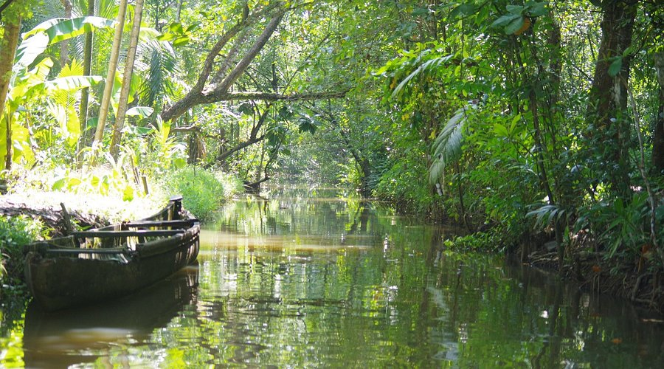
24 NOV’26: | ALLEPPEY – KUMARAKOM (35Kms, 01Hrs drive)
Morning after breakfast drive to Kumarakom. Upon arrival check in at hotel in Kumarakom. Later proceed to visit Kumarakom Bird Sanctuary – A Haven for Avian Life: Discover the tranquil Kumarakom Bird Sanctuary, set along the lush banks of Lake Vembanad, Kerala’s largest lake. The story of this enchanting sanctuary dates back to 1847, when Alfred George Baker began transforming the wetlands of what is now Kumarakom into fertile land. Of the extensive property granted to him by the local ruler, he left a portion of the southern bank of the River Kavanar untouched, planting mangroves across approximately 10 acres. Over time, this undisturbed wetland environment became a natural refuge for both resident and migratory birds. What began as an untouched stretch of mangrove habitat gradually evolved into the bird sanctuary known today as the Vembanad Bird Sanctuary. The sanctuary now encompasses approximately 14 acres and provides a protected habitat for a remarkable diversity of birdlife, with around 180 species recorded in the region. The sanctuary’s exceptional avian diversity is closely linked to its unique natural setting. Its proximity to the vast waters of Lake Vembanad, combined with fertile wetlands, abundant insects, rich vegetation, and preserved mangrove ecosystems, creates an ideal environment for birds throughout the year.

Dinner & overnight stay at hotel in Kumarakom

25 NOV’26 | KUMARAKOM
Morning after breakfast proceed for Kumarakom Village Tour.

Dinner & overnight stay at hotel in Kumarakom

26 NOV’26: | KUMARAKOM – KOVALAM (179Kms, 04Hrs drive)
Morning after breakfast drive to Kovalam. Upon arrival check in at hotel in Kovalam.

Later enjoy the Ayurveda Therapy session.

Dinner & overnight stay at hotel in Kovalam
27 NOV’26: | KOVALAM
Enjoy the Ayurveda Therapy session.

Dinner & overnight stay at hotel in Kovalam
28 NOV’26: | KOVALAM
Enjoy the Ayurveda Therapy session.

Dinner & overnight stay at hotel in Kovalam

29 NOV’26: | KOVALAM – TRIVANDRUM – DEPART TRIVANDRUM
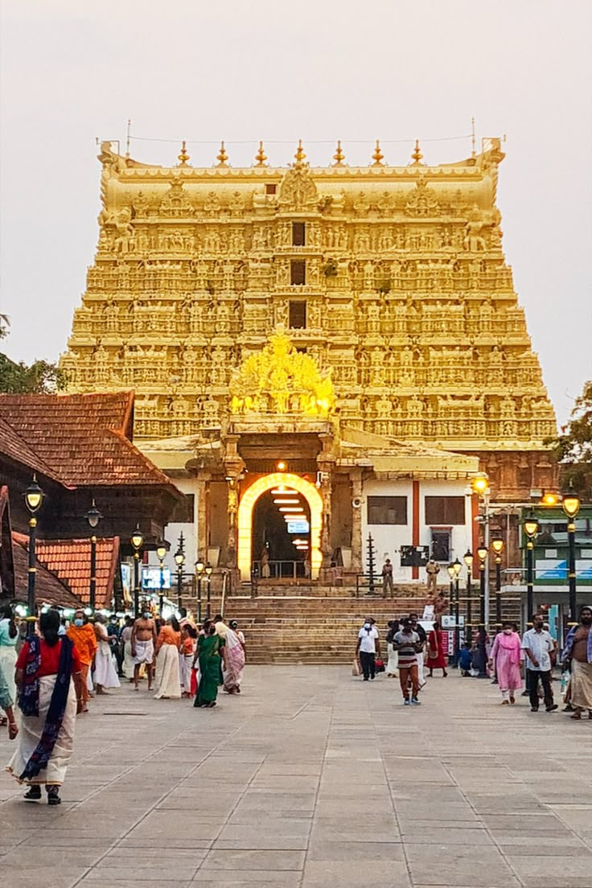
Morning after breakfast check out from the hotel and proceed for sightseeing tour of Trivandrum – Heritage, Art and Royal Elegance: Embark on a half-day sightseeing tour of Trivandrum, the elegant capital of Kerala, where centuries-old traditions, royal heritage, art, and natural beauty come together to create a fascinating introduction to the region. Begin with a visit to the magnificent Sri Padmanabhaswamy Temple, an iconic landmark of Trivandrum with a history spanning more than two centuries. Dedicated to Lord Vishnu, the temple is renowned for its imposing Dravidian-style architecture, richly carved details, and profound spiritual significance. Entry into the temple is restricted to Hindus. Continue to the Napier Museum, an impressive Indo-Saracenic structure housing an exceptional collection of archaeological and artistic treasures, including traditional bronzes, sculptures, ivory carvings, and other works representing Kerala’s rich cultural heritage. Adjacent to the museum, visit the Sri Chitra Art Gallery, celebrated for its distinguished collection of Indian paintings. The gallery offers an enriching insight into the country’s artistic traditions, with works representing classical, modern, and regional schools of Indian art. The Napier Museum and Sri Chitra Art Gallery are closed on Monday and Wednesday mornings. The sightseeing continues with the Zoological Gardens and Reptile House, offering an opportunity to discover Kerala’s diverse wildlife in a verdant setting. Conclude the cultural exploration with a visit to the Observatory, one of the city’s historic landmarks associated with the study and observation of the skies. Also visit the graceful Kanakakunnu Palace, an elegant former royal venue admired for its distinctive Indo-Saracenic architecture, ornamental stucco work, graceful domes, and beautifully crafted arches. Set amidst attractive landscaped surroundings, the palace provides a glimpse into the refined lifestyle and architectural heritage of the erstwhile Travancore royal era.

Later drop at airport to board flight for onward destination.

TOUR COST:
CATEGORY | COST PER PERSON
Towards the cost for 9 paying pax using Tempo Traveller (11 Seater) | Euro 1503 per person
Supplement for Urbania (12 Seater) for the tour | Euro 733/-
Single Room Supplement | USD 705 per Single

CiTY | HOTEL 4 STAR | LINKS | NIGHTS
Chennai | The Residency or similar | The Residency | 01 Night
Mahabalipuram | MGM Beach Resort or similar | MGM Beach Resort | 01 Night
Pondicherry | The Residency Towers or similar | The Residency Towers | 01 Night
Tanjore | Hotel Sangam or similar | Hotel Sangam | 02 Night
Madurai | Sterling V Grand or similar | Sterling V Grand | 02 Night
Periyar | Elephant court or similar | Elephant Court Periyar | 01 Night
Alleppey | Luxury House Boat | Luxury Houseboat | 01 Night
Kumarakom | Lake Song or similar | Lake Song Resort | 02 Night
Kovalam | Travencore Heritage or similar | Travencore Heritage Beach Resort | 03 Night
Total number of nights |  |  | 14 Nights

Our prices include:

Accomodation based on Double room.

Half Board basis as per program (Breakfast, Dinner) and full board in Kovalam

All arrival/departure transfer, sightseeing tour excursions by Air-conditioned Tempo Traveller.

Entrance fees to Monuments

Italian speaking guide from 15 Nov till 26 Nov’26 and on 29 Nov’26 during Trivandrum sightseeing as per program

Daily Yoga in Morning and Meditation in the Evening

Ayurveda meals

Daily doctor ’s consultation

Daily at 14:30Hrs treatment (As per doctor ‘s prescription)

Village tour of Kumarakom

Spice plantation tour in Periyar

Boat ride at Lake Periyar

01 night in Chennai with breakfast and Dinner basis.

01 night in Mahabalipuram with breakfast and Dinner basis.

01 night in Podicherry with breakfast and Dinner basis.

02 night in Tanjore with breakfast and Dinner basis.

02 night in Madurai with breakfast and Dinner basis.

01 night in Periyar with breakfast and Dinner basis.

01 night in Alleppey with full board basis.

02 night in Kumarakom with breakfast and Dinner basis.

03 night in Kovalam with full board basis.

Government tax.

Our prices do not include:

Air fare

Entry visa.

Visas can be obtained online at: www.indianvisaonline.gov.in

Tips for guides (at the client's discretion).

Travel and cancellation insurance (optional).

Beverages.

Any services not mentioned as included, including personal extras such as telephone calls, laundry

service, etc.

